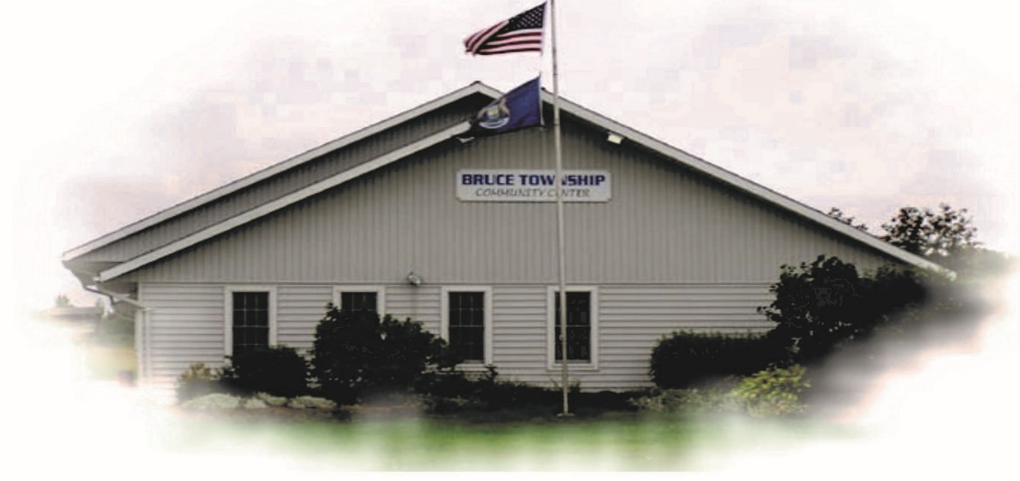
BRUCE TOWNSHIP SPRING CLEAN-UP 2023
GREEN FOR LIFE
(GFL)
3239 W. M-28, Brimley, MI 49715
Phone 906-635-3380
HOURS 8: A M TO 5: P M
CLOSED Saturday’s and Sunday’s
Cleanup will be May 15, thru June 8, 2023

Township voucher pays for the initial 350 LBS After Initial 350 LBS the cost is .05 PER LB
PLEASE TARP ALL LOADS

ITEMS NOT ACCEPTED
Hazardous Materials, Liquid Paint, Tires & Fluorescent light bulbs, Air conditioners, and other appliances, OR Household Trash (exception for REFRIGERATORS $15.00 FEE).
PICK UP VOUCHERS AT THE TOWNSHIP OFFICE
M-T-W-T-F 10 A M to 4 P M

