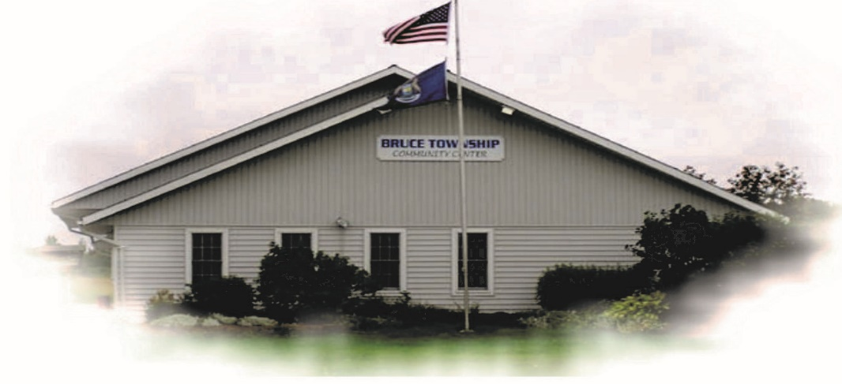

BRUCE TOWNSHIP BOARD BUDGET WORK SESSION

March 5, 2021

Work session was called to order at 12 A.M.

Board Members: R. LaJoie, C. Marsh, W. Pulfrey

Purpose of the work session was the discuss potential changes in format of the 2021-2022 budget.

Work Session was adjourned

